Apply Regularization & Dimension Reduction Methods using Boston Data

QUESTION:9

We will now derive the Bayesian connection to the lasso and ridge regression discussed in Section

(a) Suppose that yi = β0+)p j=1 xijβj +"i where "1,..., "n are independent and identically distributed from a N(0, σ2) distribution. Write out the likelihood for the data.
Code:
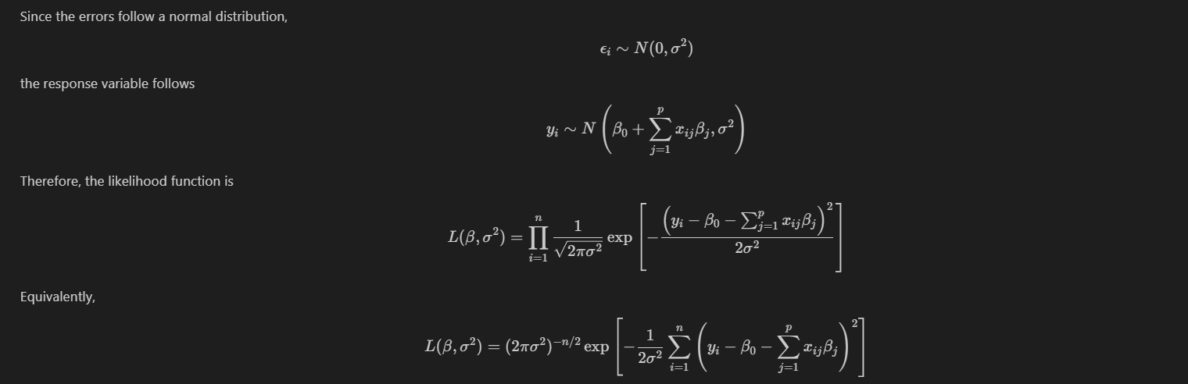
(b) Assume the following prior for β: β1,..., βp are independent and identically distributed according to a double-exponential distribution with mean 0 and common scale parameter b: i.e.p(β)= 12b exp(−|β|/b). Write out the posterior for β in this setting.
Code:
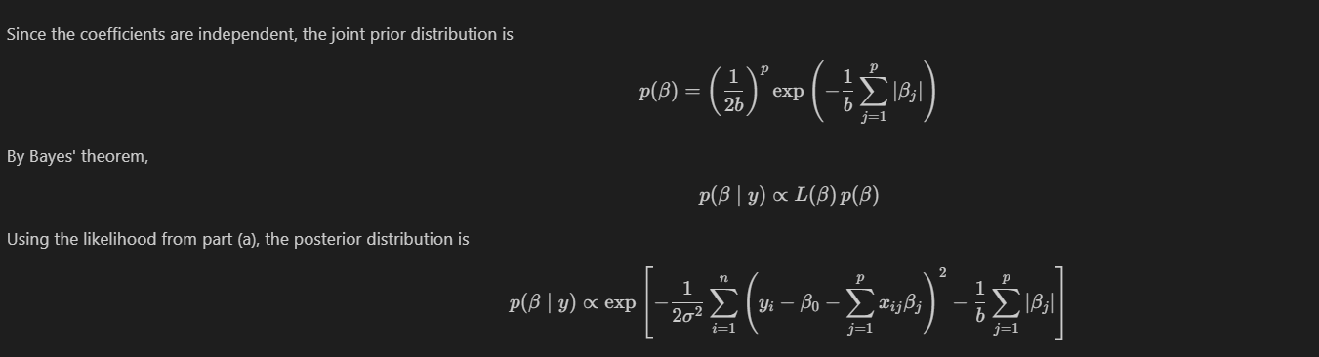

(c) Argue that the lasso estimate is the mode for β under this posterior distribution.
Code:
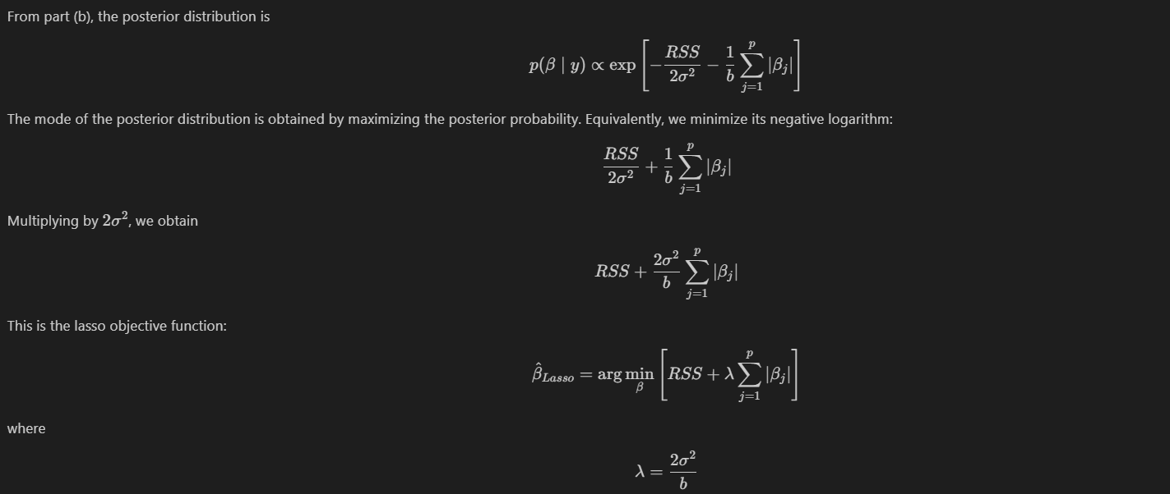
(d) Now assume the following prior for β: β1,..., βp are independent and identically distributed according to a normal distribution with mean zero and variance c. Write out the posterior for β in
this setting.
Code:
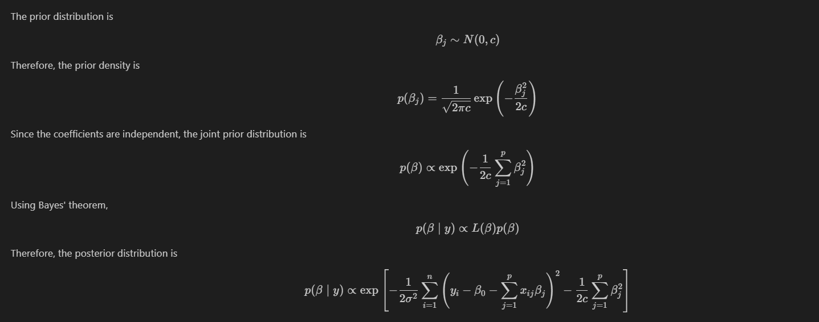

(e) Argue that the ridge regression estimate is both the mode and the mean for β under this posterior distribution.
Code:
